- Implement menu-driven program to implement Stack using Array to perform all basic operations: PUSH, POP, PEEK, isEmpty, isFull, and DISPLAY

#include <stdio.h>
#include <stdlib.h>
#define SIZE 5

int top = -1;
int stack[SIZE];

int isEmpty()
{
if (top == -1)
return 1;
return 0;
}
int isFull()
{
if (top == SIZE - 1)
return 1;
return 0;
}

int main()
{
int ch;
do
{
printf(" ====> Stack Operations <==== \n");
printf(" 1. Push\n 2. Pop\n 3. Peek\n 4. Display\n 5. Exit\n\n");
printf("Enter Your Choice: ");
scanf("%d", &ch);

switch (ch)
{
case 1:
if (isFull() == 1)
printf("Stack is OverFlow ...\n");
else
{
printf("Enter Your Value for Push: ");
scanf("%d", &stack[++top]);
printf("Element Push Successfully in Stack ....\n");
}
break;

case 2:
(isEmpty() == 1) ? printf("Stack is UnderFlow ...\n") : printf("Element Pop Successfully in Stack ....\n");
break;

case 3:
(isEmpty() == 1) ? printf("Stack is UnderFlow ...\n") : printf("%d is Peep in Stack ....\n", stack[top]);
break;

case 4:
if (isEmpty() == 1)
printf("Stack is UnderFlow ...\n");
else
{
for (int i = top; i >= 0; i--)
printf("%d\t", stack[i]);
printf("\n");
}
break;

case 5:
printf("Exiting...\n");
break;

default:
printf("Invalid Choice ... \n");
}
} while (ch != 5);
return 0;
}

Output:

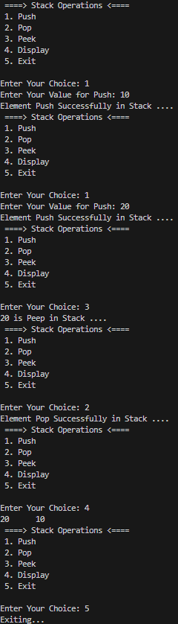
- Implement program to convert infix to postfix expression.

#include <stdio.h>
int main()
{
char infix[200], postfix[200], stack[200];
int top = -1, j = 0;

printf("Enter Your Infix Expression: ");
scanf("%[^\n]", infix);

for (int i = 0; infix[i] != '\0'; i++)
{
switch (infix[i])
{
case '(':
stack[++top] = infix[i];
break;

case ')':
while (stack[top] != '(')
postfix[j++] = stack[top--];
stack[top--];
break;

case '^':
while (stack[top] != '^')
postfix[j++] = stack[top--];
stack[++top] = infix[i];
break;

case '*':
case '/':
while (stack[top] == '^' || stack[top] == '*' || stack[top] == '/')
postfix[j++] = stack[top--];
stack[++top] = infix[i];
break;

case '+':
case '-':
while (stack[top] == '^' || stack[top] == '*' || stack[top] == '/' || stack[top] == '+' || stack[top] == '-')
postfix[j++] = stack[top--];
stack[++top] = infix[i];
break;

case ' ':
continue;

default:
postfix[j++] = infix[i];
}
}

while (stack[top] != -1)
{
if (stack[top] != '(')
postfix[j++] = stack[top--];
else
stack[top--];
}

printf("Infix Expression: %s\n", infix);
printf("Postfix Expression: %s\n\n", postfix);
return 0;
}

Output:

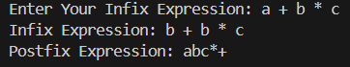

- Implement Program to Evaluate Prefix Expression.

#include <stdio.h>
#include <string.h>
int main()
{
char prefix[200];
int stack[200], top = -1, i, firstValue, secondValue;

printf("Enter Your Prefix Expression: ");
scanf("%[^\n]", prefix);

for (i = strlen(prefix) - 1; i >= 0; i--)
{
if (prefix[i] == ' ')
continue;

if (prefix[i] >= '0' && prefix[i] <= '9')
stack[++top] = prefix[i] - '0';
else
{
firstValue = pop();
secondValue = pop();

switch (prefix[i])
{
case '+':
stack[++top] = firstValue + secondValue;
break;

case '-':
stack[++top] = firstValue - secondValue;
break;

case '*':
stack[++top] = firstValue * secondValue;
break;

case '/':
if (secondValue == 0)
{
printf("Division by Zero Error\n");
return 0;
}
stack[++top] = firstValue / secondValue;
break;

case '^':
firstValue = 1;
for (int j = 0; j < secondValue; j++)
firstValue = firstValue * secondValue;
break;

default:
printf("Invalid Operator\n");
return 0;
}
}
}
printf("Prefix Expression: %s\n", prefix);
printf("Result: %d\n", stack[top--]);
return 0;
}

Output:

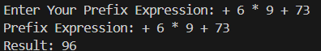

- Implement menu-driven program to implement Simple Queue using Array to perform operations: INSERT (Enqueue), DELETE (Dequeue), PEEK, and DISPLAY.

#include <stdio.h>
int main()
{
int front = -1, rear = -1, simpleQueue[5], ch;
do
{
printf(" ====> Simple Queue Operations <==== \n");
printf(" 1. Enqueue\n 2. Dequeue\n 3. Peek\n 4. Display\n 5. Exit\n\n");
printf("Enter Your Choice: ");
scanf("%d", &ch);

switch (ch)
{
case 1:
if (rear == 5 - 1)
printf("Simple Queue is Empty ... \n");
else
{
printf("Enter Your Value: ");
scanf("%d", &simpleQueue[++rear]);
front = 0;
printf("%d is inserted succeffully ... \n", simpleQueue[rear]);
}
break;

case 2:
if (front == rear)
{
front = rear = -1;
printf("Queue is Empty ... \n");
}
else
printf("%d is deleted succeffully ... \n", simpleQueue[front++]);
break;

case 3:
(front == -1) ? printf("Simple Queue is Empty ... \n") : printf("%d is peeked ... \n", simpleQueue[front]);
break;

case 4:
if (front == -1)
printf("Simple Queue is Empty ... \n");
else
{
for (int i = front; i <= rear; i++)
printf("%d\t", simpleQueue[i]);
printf("\n");
}
break;

case 5:
printf("Exiting...\n");
break;

default:
break;
}
} while (ch != 5);
return 0;
}

Output :

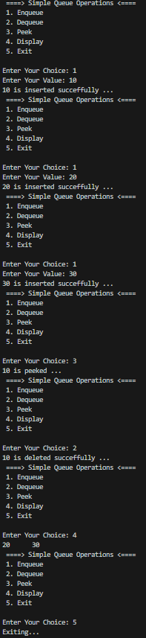

- Implement menu-driven program to implement Circular Queue using Array to perform operations: INSERT (Enqueue), DELETE (Dequeue), and DISPLAY

#include <stdio.h>
int front = -1, rear = -1, circularQueue[5];

void enqueue()
{
int value;

printf("Enter Your Value: ");
scanf("%d", &value);

if (front == -1 && rear == -1)
{
front = rear = 0;
printf("%d is inserted succefully ... \n", circularQueue[rear] = value);
}

else if (rear == front - 1)
printf("Queue is Full ... \n");

else if (front != 0)
{
if (rear == 5 - 1)
{
rear = 0;
printf("%d is inserted succefully ... \n", circularQueue[rear] = value);
}

else
printf("%d is inserted succefully ... \n", circularQueue[++rear] = value);
}

else if (rear == 5 - 1)
printf("\n Queue Is Empty ... \n");

else
printf("%d is inserted succefully ... \n", circularQueue[++rear] = value);
}

int main()
{
int ch;
do
{
printf(" ====> Circular Queue Operations <==== \n");
printf(" 1. Enqueue\n 2. Dequeue\n 3. Display\n 4. Exit\n\n");
printf("Enter Your Choice: ");
scanf("%d", &ch);

switch (ch)
{
case 1:
enqueue();
break;

case 2:
(front == rear) ? printf("\n Queue Is Empty ... \n") : printf("\n %d Deleted Successfully ...\n", circularQueue[front++]);
break;

case 3:
for (int i = front; i <= rear; i++)
printf("%d \t", circularQueue[i]);
printf("\n");
break;

case 4:
printf("Exiting...\n");
break;

default:
printf("You Have chhose Wrong Options");
break;
}
} while (ch != 5);
return 0;
}

Output :

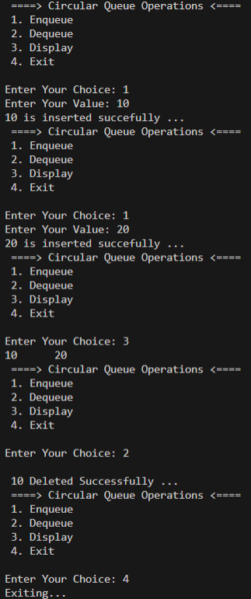

- Implement menu-driven program to perform Searching Techniques to search for an element in an array using both Linear Search and Binary Search algorithms.

#include <stdio.h>
int main()
{
int choice, arr[5], value, found = 0, low = 0, high = 5 - 1, mid;
do
{
printf("\n====> Searching Techniques <====\n");
printf("1. Input Array\n 2. Linear Search\n 3. Binary Search\n 4. Display Array\n 5. Exit\n\n");
printf("Enter Your Choice: ");
scanf("%d", &choice);

switch (choice)
{
case 1:
printf("Enter %d Elements in Sorted Order:\n", 5);
for (int i = 0; i < 5; i++)
scanf("%d", &arr[i]);
printf("Array Inserted Successfully\n");
break;

case 2:
printf("Enter Value to Search: ");
scanf("%d", &value);

for (int i = 0; i < 5; i++)
if (arr[i] == value)
{
printf("Value Found at Position %d\n", i + 1);
found = 1;
break;
}
if (found == 0)
printf("Value Not Found\n");
break;

case 3:
printf("Enter Value to Search: ");
scanf("%d", &value);

while (low <= high)
{
mid = (low + high) / 2;
if (arr[mid] == value)
{
printf("Value Found at Position %d\n", mid + 1);
found = 1;
break;
}
else if (arr[mid] < value)
low = mid + 1;
else
high = mid - 1;
}
if (found == 0)
printf("Value Not Found\n");
break;

case 4:
printf("Array Elements:\n");

for (int i = 0; i < 5; i++)
printf("%d\t", arr[i]);
printf("\n");
break;

case 5:
printf("Exiting...\n");
break;

default:
printf("Invalid Choice\n");
}
} while (choice != 5);
return 0;
}

Output :



